Updated 12/2019

INITIAL STEPS
IN EARLY CHILDHOOD EDUCATION AND CARE IN THE MUNICIPALITY OF LOHJA

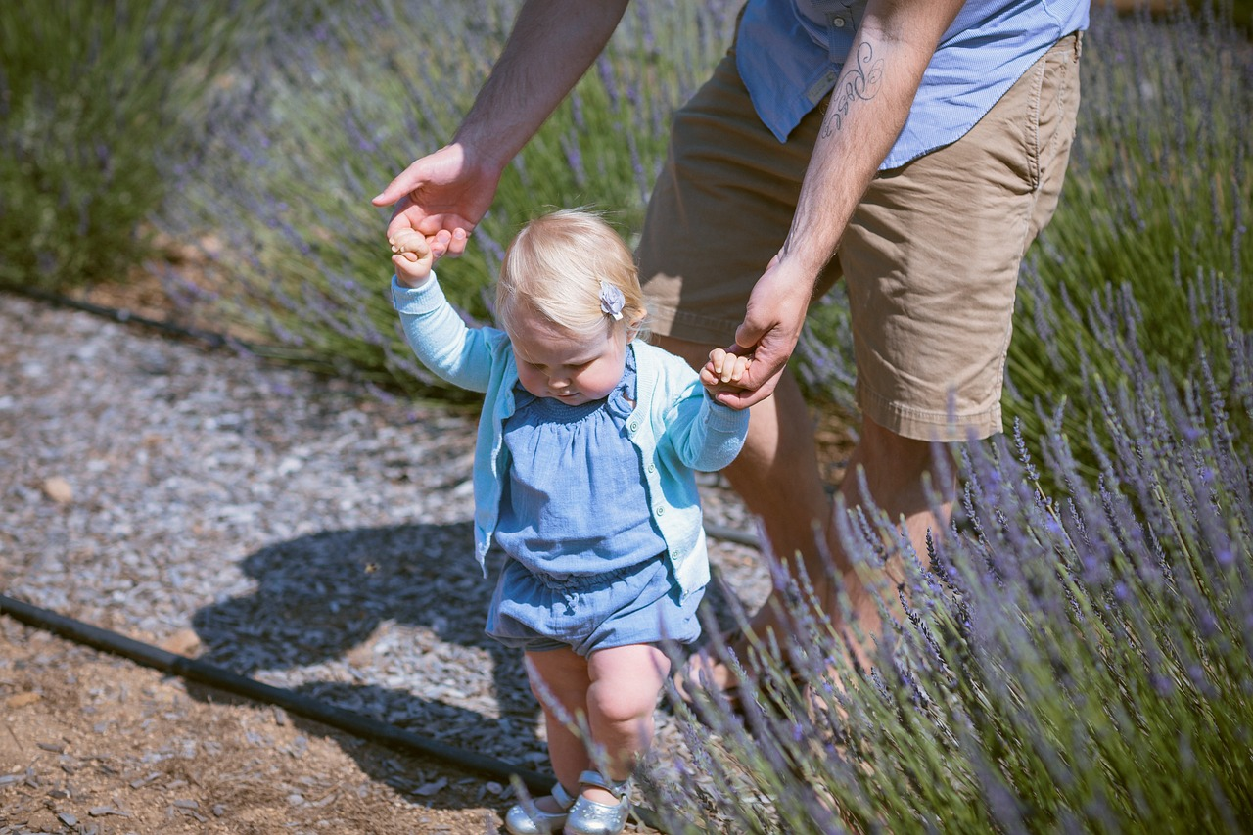

CONTENTS

1. Introduction

2. Call from the day care centre director / service supervisor (if required)

3. Decision on early childhood education and care

4. Call from the early childhood education and care group

5. Care start discussion

6. Orientation policy

Attachments
- Information on the care start progress
- Care start checklist (for the employee)

1. INTRODUCTION
You are reading the Initial Steps materials. The aim is to build uniform practices for the start of early childhood education and care in the municipality of Lohja. The purpose of this material is to provide employees with instructions on how to encounter a new child and their guardian at the beginning of care. The Initial Steps material focuses on the start of care at day care centres, but they can also be easily applied to other types of early childhood education and care.

When a child is granted a place in the early childhood education and care services, their guardians will receive the decision on it via eServices or by post about one month before the desired start date of care. If necessary, the service supervisor or a day care centre director will contact the guardian before a place is granted in the early education and care services.
Next, the guardians will be contacted by the future early childhood education and care group or family day care services. Practices related to orientation and the start of care will be agreed on during this call.

2. CALL FROM THE DAY CARE CENTRE DIRECTOR / SERVICE SUPERVISOR (if required)
Details on the matters related to the care decision and the start of care and a discussion on the child's upcoming attendance in early childhood education and care.
- The start date of care must be agreed on with the guardian, and the goal is to make the start of care as smooth as possible for the child.

3. EARLY CHILDHOOD EDUCATION AND CARE DECISION
The early childhood education and care decision to be sent to the guardians will include:
- A background information form
- Instructions on submitting income information
- A link for confirming/cancelling the child’s attendance in early childhood education and care

4. CALL FROM THE EARLY CHILDHOOD EDUCATION AND CARE GROUP
The early childhood education and care group will contact the guardians well before the care begins. The time and place of the first meeting will be agreed upon during the call, and starting the care smoothly for the child will be discussed. The Lohja municipality recommends an in-home start of care discussion, at least for children under the age of 3.
5. START OF CARE DISCUSSION
To be conducted at home, in family day care or at a day care centre. The practices of the orientation period will be agreed upon during the discussion.
- Directions to use the unit's peda.net site
- An early childhood education and care plan for the child
- Start of care checklist (for the employee)
- Background information and permissions form
- Background information form (under/over 3 years of age)

6. ORIENTATION POLICY
Before the orientation, the early childhood educator conducts a start of care discussion with the guardians. This discussion can be held in the child's home or the care facility. The purpose of the start of care discussion is to hear the guardians’ thoughts about their child and to listen to their wishes and questions related to the start of care and early childhood education and care. The details shared by the guardians about their child will be taken into account at the start of early childhood education and care.
The advantage of the start of care discussion conducted in the child’s home is that, in a familiar environment, the child feels safe, which often makes it easier to get acquainted with the child. In this way, when the child comes to the place of care for the first time, they already have one familiar adult there who will show the environment to the child and the guardian. The orientation will be agreed on in the start of care discussion.
It is desirable for the child and the guardian to visit the group and its activities at different times on different days.

Initial Steps in early childhood education and care in the municipality of Lohja

1. A written decision on early childhood education and care and possibly a call to the family
- Background information form
- Instructions on submitting income information
- A link for confirming/cancelling the child’s attendance to early childhood education and care

2. The care group will contact the family and agree on how to get acquainted.

3. An in-home visit (or, if you wish, a meeting at the day care centre)
- The start of care discussion, in which the practices of the orientation period will be agreed on

4. Smooth beginning of early childhood education and care
- The orientation visits to the day care group are agreed on with the early childhood educator

5. Start of care
- It is recommended that in the beginning, the daily hours that the child spends in day care are short.
- The invoicing of early childhood education begins when the child stays in the care without their guardian for the first time

START OF CARE CHECKLIST
REMEMBER TO LISTEN TO THE CUSTOMER! - A list to support your work Date:

Name of child: | Early childhood educator:

Family members
Thoughts about the child starting the care
Wishes and expectations for early childhood education and care
Child's strengths and interests
(the child)
Child's strengths and interests
(guardians)
Attitude towards others
(children, adults)
Previous experiences of being separated from the guardians
Possible concerns

Important to know and take into account
Meals
Napping practices
(the child sleeps/rests)
Using the toilet
(nappies, if any)
Allergies
(a medication plan)
Dressing/clothes
(spare clothes)
Expressions of feelings
(happy, sad, missing parents, cold, hungry)
Comfort items
Child's early childhood education and care plan,
Permissions and background information form,
Peda.net website
Orientation visits
(Start of care progress)
The guardian can always call to check how the child is doing!

